Module 5

Assignment 5.2
Course: CSD402-340A Java for Programmers
Prepared By: Mirach Erkol
Date of Report: 2/8/2026

https://github.com/Mikey5007/csd-402.git

5.2 Assignment:
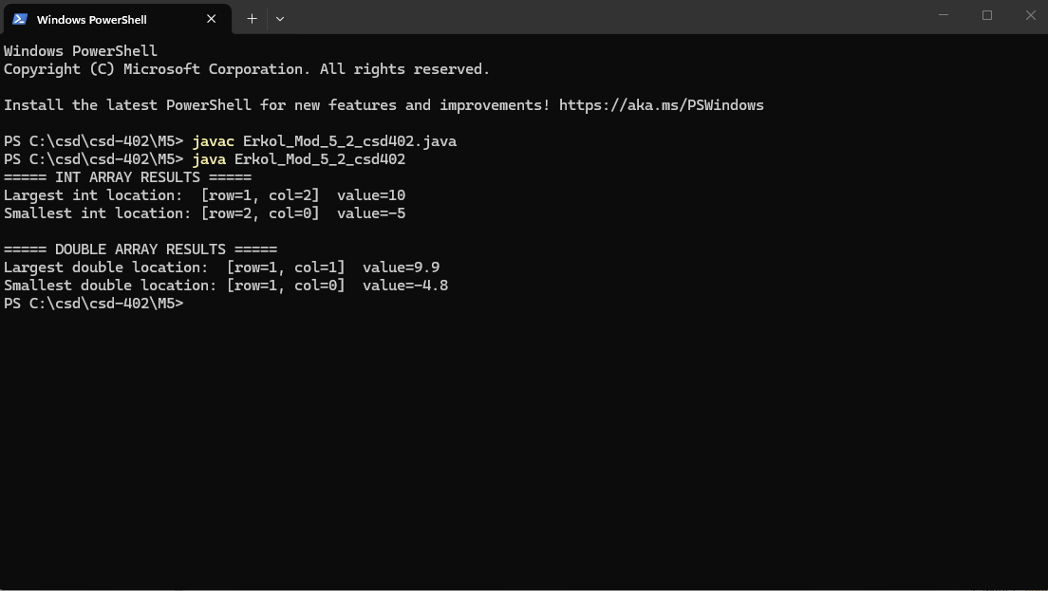

References:

https://github.com/Mikey5007/csd-402.git

